**Make comparison of the advantages and disadvantages between procedural programming and object-oriented programming. Give clear explanation of each characteristic for the comparison. (M3.4)**

1. Advantages

|  |  |  |
| --- | --- | --- |
| Characteristic | Object-oriented Programming | Procedural Programming |
| Reusability |  |  |
|  |  |  |
|  |  |  |

2. Disadvantages

|  |  |  |
| --- | --- | --- |
| Characteristic | Object-oriented Programming | Procedural Programming |
|  |  |  |
|  |  |  |
|  |  |  |

**Implement and justify error-handling or precaution imposed in your system to prevent any failure caused by inappropriate inputs from user. Provide print screen(s) for the implemented error-handling. (D2.4)**

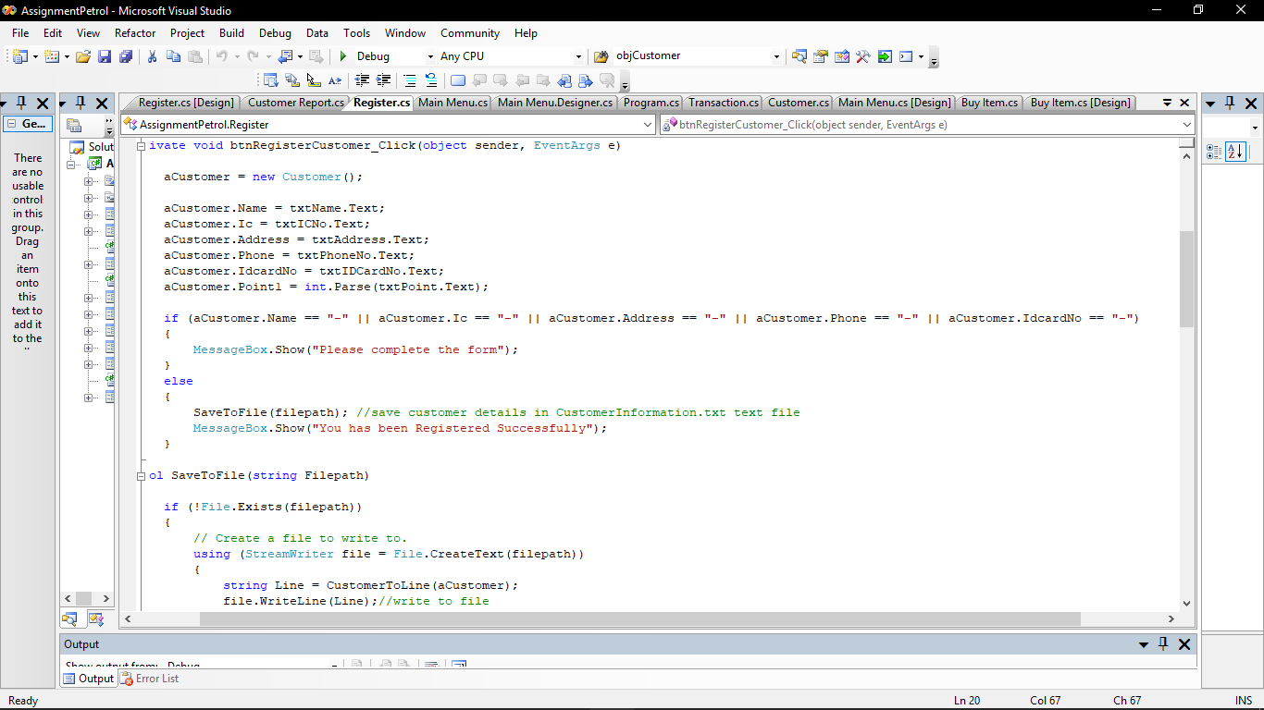1.

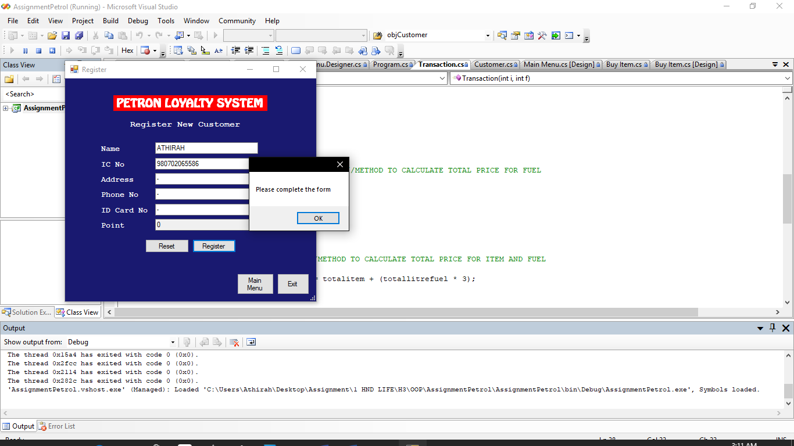

Above is the screenshot of the first error-handling that is implemented in the Customer Loyalty Program. The error-handling is implemented in the Register form where the users need to fill in all the customers’ details. If the users do not fill in one of the customers’ detail and click the register button, the message box will appear with message “Please complete the form”. But if user fill in all the customers’ details in text box, the system will save the customers’ detail in text file named CustomerInformation.txt. This error-handling is implemented to from the date save to be saved in null value.

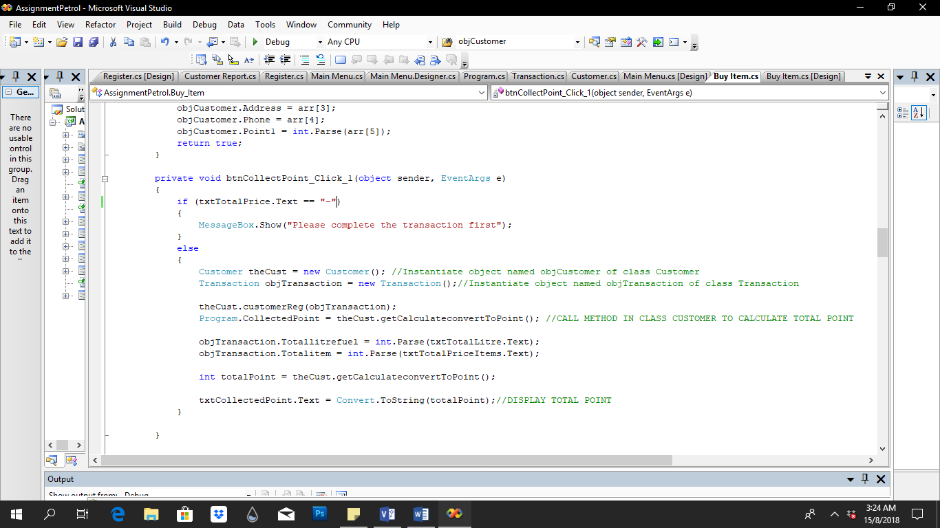2.

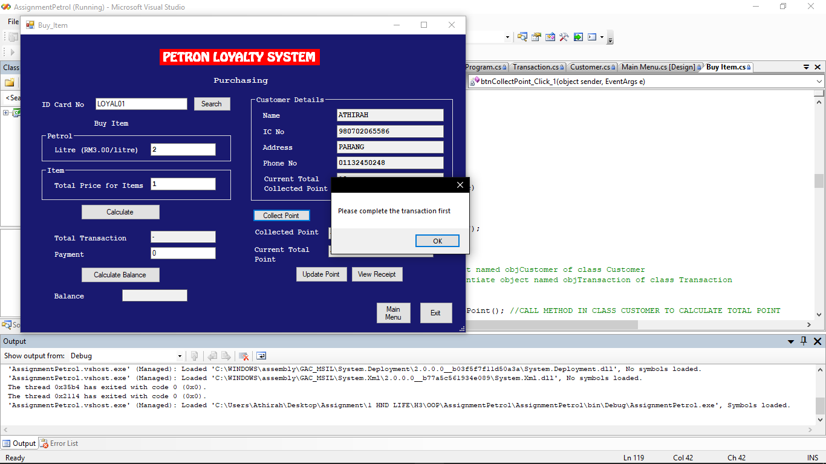

Above is the screenshot of another error-handling that is implemented in the system. The error-handling is implemented in Buy Item form where user need to complete the transaction of the sale before click the button Collect Point to collect the point of the transaction. If user do not complete the transaction which the users do not enter the button calculate, but just straight forward by clicking the Collect Point button, the message box will display message “Please complete the transaction first”. But if the users complete the transaction, the total collected point from the transaction will be calculated and displayed in the text box. This error-handling is implemented because the total point cannot be calculated if the total price of the transaction is not calculated.

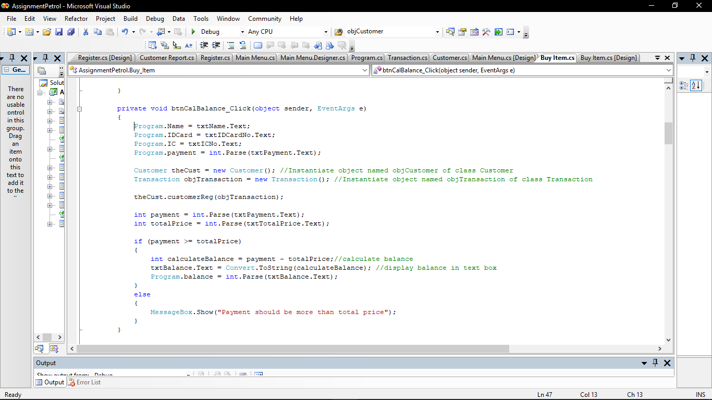

3.

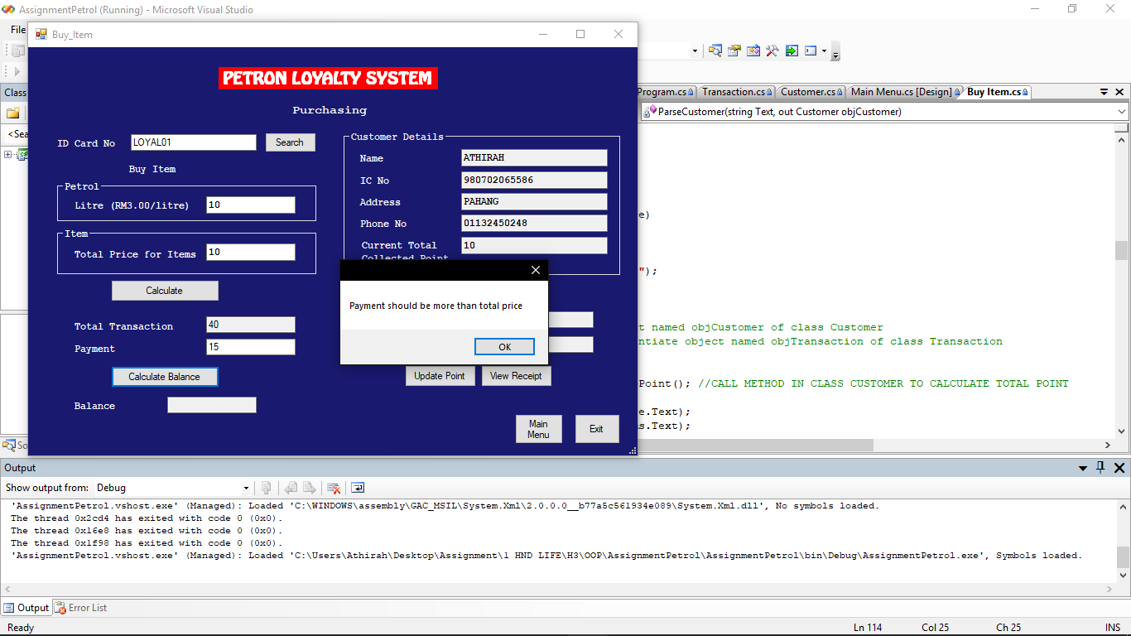

Above is the last error-handling that is implemented in the system. The error handling is implement in the Buy Item form. It happens in the button Calculate Balance where the users need to enter the payment more than or equal to the total price. If the total price is 40, then the user only enters 15 for the payment, the message box will appear with a message “Payment should be more than total price”. But when user enter the payment more than total price, the system will calculate the balance of the payment. This error-handling is implemented because it if the payment is less than total price, the balance of the transaction will be in negative answer.